Quyidagi interfeys uchun berilgan modeldan foydalanib ma’lumotlar strukturasini *output*da ko’rsatilgan formatda daraxt ko’rinishida REST API ga chiqarib bering.

*>Kredit to’lovlarini formulasi bilan hisoblash shart emas, klient o’zi bittalab kiritib chiqadi*

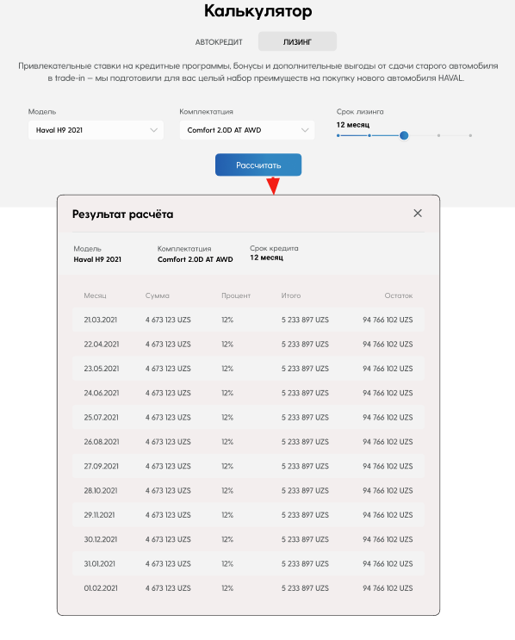

Modellar:

*class Cridet(models.Model):  
 CHOICE = (  
 (1, _('Credit')),  
 (2, _('Leasing')),  
 )  
  
 car = models.ForeignKey(Car, on_delete=models.CASCADE, related_name='cridets')  
 model = models.ForeignKey(PositionCategory, on_delete=models.CASCADE, related_name='cridets')  
 month = models.IntegerField(default=12)  
 status = models.IntegerField(choices=CHOICE)  
 created_at = models.DateTimeField(auto_now_add=True)  
 updated_at = models.DateTimeField(auto_now=True)  
  
 def __str__(self):  
 return str(self.month)  
  
 @property  
 def model_title(self):  
 return self.model.title  
  
  
class Payment(models.Model):  
 credit = models.ForeignKey(Cridet, on_delete=models.CASCADE, related_name='payments')  
 order = models.IntegerField(default=1)  
 sum = models.FloatField(default=0)  
 percent = models.FloatField(default=12)  
 total = models.FloatField(default=0)  
 remain = models.FloatField(default=0)  
  
 def __str__(self):  
 return str(self.order)*

*output:*

{

"credit": [

{

"id": 3,

"title": "H9",

"models": [

{

"id": 5,

"title": "Dignity",

"credit": [

{

"month": 2,

"payments": [

{

"id": 21,

"order": 1,

"sum": 0,

"percent": 12,

"total": 0,

"remain": 0

},

{

"id": 22,

"order": 2,

"sum": 0,

"percent": 12,

"total": 0,

"remain": 0

}

]

}

]

}

]

},

{

"id": 2,

"title": "H6",

"models": [

{

"id": 4,

"title": "Supreme",

"credit": [

{

"month": 6,

"payments": [

{

"id": 15,

"order": 1,

"sum": 0,

"percent": 12,

"total": 0,

"remain": 0

},

{

"id": 16,

"order": 2,

"sum": 0,

"percent": 12,

"total": 0,

"remain": 0

},

{

"id": 17,

"order": 3,

"sum": 0,

"percent": 12,

"total": 0,

"remain": 0

},

{

"id": 18,

"order": 4,

"sum": 0,

"percent": 12,

"total": 0,

"remain": 0

},

{

"id": 19,

"order": 5,

"sum": 0,

"percent": 12,

"total": 0,

"remain": 0

},

{

"id": 20,

"order": 6,

"sum": 0,

"percent": 12,

"total": 0,

"remain": 0

}

]

},

{

"month": 18,

"payments": [

{

"id": 25,

"order": 1,

"sum": 0,

"percent": 12,

"total": 0,

"remain": 0

},

{

"id": 26,

"order": 2,

"sum": 0,

"percent": 12,

"total": 0,

"remain": 0

},

{

"id": 27,

"order": 3,

"sum": 0,

"percent": 12,

"total": 0,

"remain": 0

},

{

"id": 28,

"order": 4,

"sum": 0,

"percent": 12,

"total": 0,

"remain": 0

},

{

"id": 29,

"order": 5,

"sum": 0,

"percent": 12,

"total": 0,

"remain": 0

},

{

"id": 30,

"order": 6,

"sum": 0,

"percent": 12,

"total": 0,

"remain": 0

},

{

"id": 31,

"order": 7,

"sum": 0,

"percent": 12,

"total": 0,

"remain": 0

},

{

"id": 32,

"order": 8,

"sum": 0,

"percent": 12,

"total": 0,

"remain": 0

},

{

"id": 33,

"order": 9,

"sum": 0,

"percent": 12,

"total": 0,

"remain": 0

},

{

"id": 34,

"order": 10,

"sum": 0,

"percent": 12,

"total": 0,

"remain": 0

},

{

"id": 35,

"order": 11,

"sum": 0,

"percent": 12,

"total": 0,

"remain": 0

},

{

"id": 36,

"order": 12,

"sum": 0,

"percent": 12,

"total": 0,

"remain": 0

},

{

"id": 37,

"order": 13,

"sum": 0,

"percent": 12,

"total": 0,

"remain": 0

},

{

"id": 38,

"order": 14,

"sum": 0,

"percent": 12,

"total": 0,

"remain": 0

},

{

"id": 39,

"order": 15,

"sum": 0,

"percent": 12,

"total": 0,

"remain": 0

},

{

"id": 40,

"order": 16,

"sum": 0,

"percent": 12,

"total": 0,

"remain": 0

},

{

"id": 41,

"order": 17,

"sum": 0,

"percent": 12,

"total": 0,

"remain": 0

},

{

"id": 42,

"order": 18,

"sum": 0,

"percent": 12,

"total": 0,

"remain": 0

}

]

}

]

}

]

}

],

"leasing": [

{

"id": 1,

"title": "H2",

"models": [

{

"id": 6,

"title": "Intelegent",

"leasing": [

{

"month": 2,

"payments": [

{

"id": 23,

"order": 1,

"sum": 0,

"percent": 12,

"total": 0,

"remain": 0

},

{

"id": 24,

"order": 2,

"sum": 0,

"percent": 12,

"total": 0,

"remain": 0

}

]

}

]

}

]

}

]

}